External influences – Technological

Introduction:
- How technology affects businesses

p.91-97

Technology – what does it mean?

Let’s focus on high-technology machines and processes that are loosely based on information technology (IT).

Changes in technology often act as the major influence on an organisation. Any business that fails to keep pace with technological change will find that its competitive position is affected through (for example) operating outdated production equipment, using slow or inefficient communications equipment, or failing to use the internet and other e-commerce technological developments.

New products, markets or segments are created through technological developments.

Examples include:
- The worldwide mobile phone market – dumb phones versus smartphones
- Electronic downloads of music files(MP3/MP4) that replace CDs and DVDs being bought – nowadays clouds may store them or YouTube, Youku
- Developments in videoconferencing, avoiding the need to meet face to face
- Solar panel and wind technologies being used for power and heating
- 3D printing replacing some prototype manufacturing
- GPS positioning that are used with mobile devices – opportunities for businesses locations and marketing - mapping
- New materials - smaller devices - faster processors
- Power of software over hardware – apps
- Change in nature of some goods - virtual products such as Avatars, gifts that represent real life goods
- Payment methods – smartphones, payments platforms (Alipay/PayPal), ‘Quick Pass’
- Medical care – monitoring

Applying technology to business - potential limitations

Costs | Labour relations | Reliability | Data protection | Management
Capital costs  Labour costs  Redundancy | Damage to worker relations  Lower motivation levels | Breakdowns in automated production  Initial introduction problems take longer than expected | Rights to hold data on staff, customers  Legal restraints | Fear change  Managing the process of technology adoption

IT and business decision making
Using data to manage through the use of IT is referred to as ‘management information systems’ (MIS). Computers provide managers with data about the firm’s operations, often in real-time.

Benefits | Drawbacks
Managers obtain data quickly and frequently from different departments, divisions and even individual machines  Computer can analyse and process data rapidly: manager can then make quick decisions based on them  Increases the communication process to people who need to know | Data overload  Information could be centralised – loss of empowerment and authority for middle-managers

Gives substantial power and information to centralised managers

IT system | Common business application | Advantages
Word processing |  | Speed  Accuracy  Links with other programs
Databases
Spreadsheet programs

CAD

CAM
Internet/intranet

Introducing technology effectively

- Analyse -

- Involve -

- Evaluate -

- Plan -

- Monitor -

Is technology always the best solution?

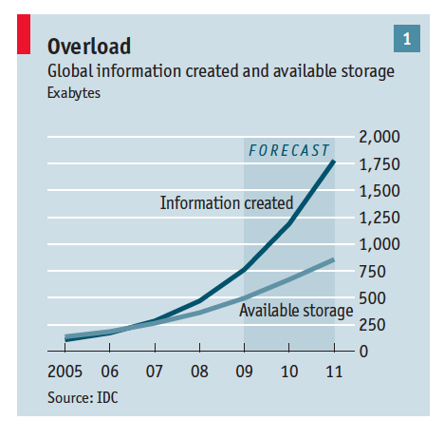

Worksheet summary quiz and activity:

- Should technology always be adopted by a business? Explain.

- Management Information Systems mean better communication. Explain.

- Disruptive technologies are perhaps one of the most important external factors that affect businesses. Choose one and explain its implication for a business.

Summary of the worksheet in your own words (in English and Chinese):

Vocabulary check:
English | Chinese
Acquisition
Handset
Livery
Holistic
Liberalisation

