External influences – Social and demographic

Introduction:
- A brief introduction to society and demographic changes
- p.96-97

The structure of society is constantly evolving. The changes occurring in many countries include:

- Ageing population – low birth rate for developed countries
- Changing role in society for women
- Increasing educational opportunities – increasing literacy, skilled and adaptable workforces
- Early retirement – increased leisure time
- Divorce rate increase in many countries – single-income households
- Job insecurity often due to globalisation forcing more employees to accept part-time, temporary or zero-hour contracts (no guaranteed work)

From China’s perspective:

Factor | Implications for business
- Implications of one-child policy

- Skewed gender ratio (male to female birth rate)

- Labour migration – rural to urban/inland to coastal

- Increasing income and creation of middle-class

- Expansion of super-rich – largest growing luxury market

- Grandparents’ involvement in child-rearing

An ageing population:

This means that the average age of the population is ri_______. It is often associated with:
- A larger proportion of the population over the age of retirement
- Smaller proportion of the population in the lower age ranges
- Smaller number of workers in the economy, but a larger number of dependants (below working age or retired) – tax burden on society

These changes often result from:

- lower birth rates (smaller families, improved birth control)
- increasing numbers of women in work
- longer life expectancy (better health and social care)
- the working population illnesses and diseases (chronic illnesses from smoking, lack of exercise, obesity, diabetes etc.)
- more single people (socially acceptable)
- the cost of raising children (especially multiple children)

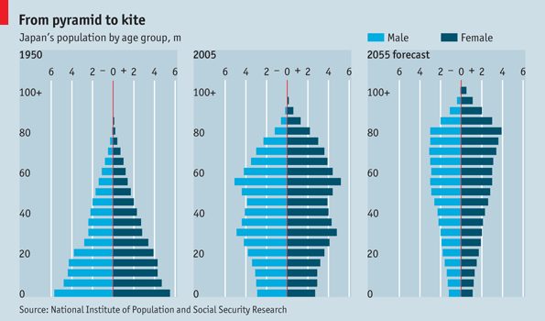

How could this affect Japan and its businesses?
Impact on business:

- changing patterns of demand for products (grey consumers – care homes, beach retirement homes, medical devices)
- age structure of workforce – increasing retirement age, skills shortage

Patterns of employment:

Changing patterns of employment are one of the constraints on the activities of business:
- labour is a crucial factor of ___________ and expense, especially in personal service industries (childcare or homes for the elderly)

The main features of changing patterns in most countries are:

- Labour being replaced by capital (especially secondary sector)

- Transfer of labour from old to new – i.e. steel to computer-games design

- Increasing number of women employed

- Increase in part-time employment

- Student employment

- Temporary and flexible employment

- Flexible hours

- Increasing burdens on the health service, pensions, private pension funds and the care industries

- Multi-cultural workforce

- More online work – allows flexibility but also destroys jobs (outsourcing)

Evaluating effects on business of the changes in the pattern of employment:

Firms can make these changes work to their own benefit, while accepting some of the cost implication of them.

Benefits | Drawbacks
Higher-quality and better-qualified workers should be more efficient…  Part-time workers offer flexibility for firms…  Women can bring diversity and a wider choice of staff… | …but they expect improved pay and conditions.  …but harder to integrate into a team and may therefore not be so effective  …but increased costs through maternity leave and covering costs

As with all other external influences on business behaviour, the most successful firms will be those that adapt to changes the most quickly and attempt to turn them into their own competitive advantage

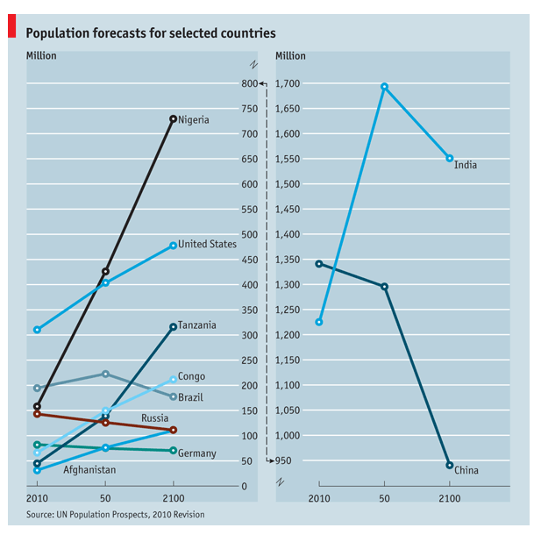
Considering the above forecasts: As an MNC who is involved in cosmetics, how could the forecast influence your company’s strategy?
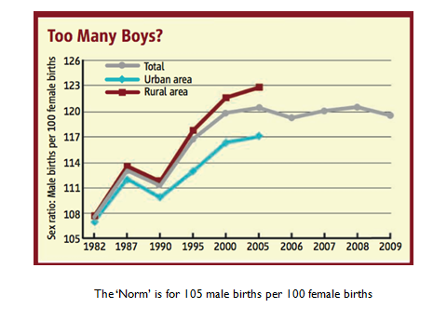
You are a large company (you choose an industry). Given the above data, how will the above affect the company’s future strategy in terms of product choice, labour policy, location and expansion?

Activity 6.7 (p.99)

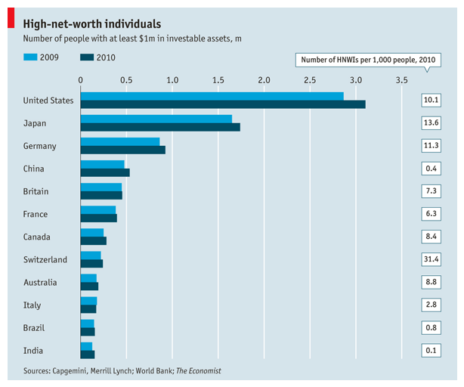

Switzerland has a lot of ‘rich’ people. Is this chart misleading?

Worksheet summary quiz and activity:

- Explain two ways in which a fast-food restaurant might be affected by an ageing population.

- Suggest how increased women in the workforce can affect a firm’s overall strategy.

- From a marketing perspective, choose one of social/demographic impacts and describe its potential marketing impact.

Summary of the worksheet in your own words (in English and Chinese):

Vocabulary check:
English | Chinese

