External influences – Economic: business cycle & inflation

Introduction:
- External influences concerning the economy – business cycle and inflation
- p110-118

Let’s start by reading the introductory topic: ‘Iceland’s economy boils over’

Consider a country’s economy:

Rate of economic growth
Rate of price inflation
Unemployment levels
Exchange rate

They can be both constraints of business activity as well as great newopportunities

Government has objectives for the nation’s economy

In pursuing these objectives, governments take economicpolicy decisions that can have a significant impact on businesses

Managers needs to be aware and understand these objectives and policies to protect their organisation from negative policy changes and take advantage of positive policy changes

Economic objectives of governments:

Economic growth
Low target rate of inflation
Low rate of unemployment
Long-term balance between the value of goods bought from other countries (imports)
And the value of the goods and services the country sells to other countries (exports)

Current account of the balance of payments account
Exchange rate stability
Wealth and income transfers to reduce inequalities

Unfortunately, several of these objectives may conflict with each other:
- By adjusting one objective, another objective is influenced
- Rate of inflation too high – policies to reduce spending
  - Lead to lower demand and thus result in increased unemployment

Economic growth – a definition and why it is considered desirable

Gross Domestic Product (GDP)

Economic growth

GDP is measured in monetary terms, and inflation will raise the value of GDP

- Such an increase is not true economic growth

- Economic growth in the economy occurs when the real level of GDP rises as a result increases in the physical output of goods and services in an economy

- Every economy is striving to achieve economic growth

Economic growth is important to a country because:

- Higher real GDP increases the quantity of goods and services available for consumers and this increases living standards
- Higher levels of output often lead to increases employment
- More resources can be allocated to public sector projects, such as health and education without reducing resources in other sectors
- Absolute poverty can be reduced or even eliminated if growth is substantial enough and benefits spread
- Businesses should experience rising demand for their products (dependant on elasticity of demand)
- Higher GDP – more resources for government - decrease burden of social expenditure (i.e. unemployment benefits) – can reduce the burden of taxation

As the book illustrates too rapid growth is not always beneficial to everyone:
- it can lead to problems such as pollution and damage to health
- …also technological change can lead to some losing their jobs

The factors that lead to economic growth
- Increases in output resulting from technological changes and expansion of industrial capacity – should not lead to inflation (no demand-pull pressures)
- Increases in economic resources, such as higher working population or discovery of new resources of oil and gas – increase when economic resources are available
- Increases in productivity – if existingresources can produce a higher level of output (compared to last year) –i.e. higher labour productivity with higher-skilled and better qualified workforce, acceptance of new technology

The business cycle:

Economies tend to grow at very different rates over time – known the business cycle
- Boom
- Downturn or recession
- Slump
- Recovery and growth

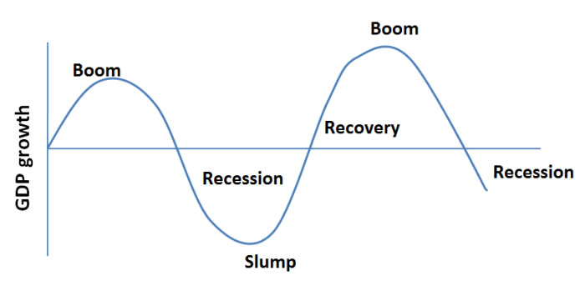

Boom | Downturn/recession | Slump | Recovery and growth
Rising incomes and profits  Inflation rises due to high demand for G&S; shortages of high-skilled workers – higher wage increases  High inflation makes an economy’s goods uncompetitive – profits are hit by higher costs  Government increases interest rates – reduce inflationary pressure  Downturn often results from this | Effect of falling demand and higher rates starts to bite  Real GDP growth slows (perhaps falls)  Technically called a recession  Incomes and consumer demand fall and profits are much reduced  Some firms record losses and some go out of business | A very serious and prolonged downturn can lead to a slump where real GDP falls substantially – house and asset prices fall  Could be tied to a governments corrective economic action such as policies and stimulus (injecting money into the economy like USA and China) | All downturns eventually lead to a recovery when real GDP starts to increase again  Could be because: governments takes corrective action or country’s products become competitive once more and demand increases

Be aware that the above is a simplified version of the economy and reasons/corrective action. It is not always possible for governments to know what the right corrective action is or indeed what ‘side effect’ or unintended consequence one policy has on another. Japan has been battling the above for 20 years – the current prime minster is trying to boost the economy but is faced with opposition from those who wish to protect their own interests. It sometimes requires more radical policy change.

Is recession all bad?

Recession:

An economic recession has serious consequences for most business and the whole economy.
- Output is falling, fewer workers will be needed; unemployment will increase, so demand for G&S declines faller. There will be less income tax and sales revenue tax received

However, some opportunities for well-managed firms could be:
- Capital assets many be relatively cheap and firms may invest for the future expected recovery
- Demand for inferior goods could actually increase
- The risk of retrenchment(reducing spending) and job losses may improve employer-employee relations and thus increased efficiency
- The difficult business climate may prompt firms to be becoming ‘leaner and fitter’ and therefore potentially more competitive when growth and recovery eventually starts again

Type of producer | Period of economic growth | Period of recession
Luxury goods and services – e.g. cars | - Increase range of G&S  - Raise prices> increase profit margins  - Promote exclusivity and style  - Increase output | - May not reduce prices for fear of damaging long-term image  - Credit terms to improve affordability  - Offer promotions (with caution)  - Widen product range with lower priced models
Normal goods and services – e.g. tinned food | - Add extra value to product – better ingredients/improved packaging  - Brand image may attract exclusive tag  - Do nothing- sales not much affected anyway | - Lower prices  - Promotions  - Do nothing – sales not much affected anyway
Inferior goods and services – e.g. very cheap clothing | - Attempt to move product upmarket  - Add extra value to the product – e.g. higher quality  - Extend the product range to include more exclusive or better designed products | - Promote good value and low prices  - Free consumer tests  - Increase range and distribution outlets

Inflation and deflation – changing the value of money

- The spending power of one dollar is the goods that can be bought for that dollar.

- The spending power of money can change over time

- If one dollar buys fewer goods this year than it did last year, then the value of money has FALLEN and this must have been caused by INFLATION

Inflation

- If one dollar buys more goods this year than it did last year, then the value of money has INCREASED and this must have been caused by DEFLATION

Deflation

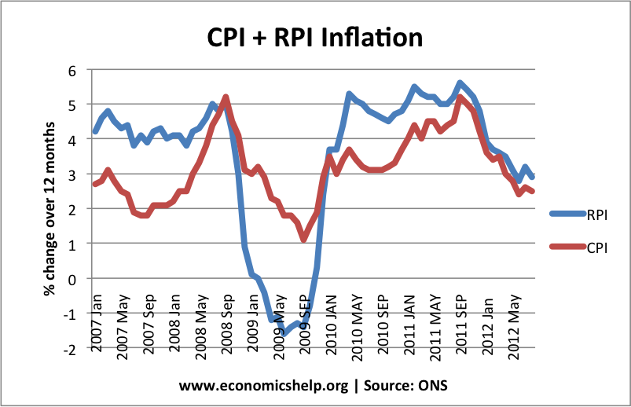

In the book, it illustrates a few examples during the 2008 (I’ve updated them):

Zimbabwe inflation rate (hyper-inflation) | This lopsided economy is a legacy of the collapse of Zimbabwe’s currency. Inflation reached an absurd 231,000,000% in the summer of 2008.A ban on foreign-currency trading was lifted in January 2009. By then the American dollar had become Zimbabwe’s main currency, a position it still holds today.  Zimbabwe’s dollar had been too liberally printed: a swollen stock of local banknotes was chasing a diminished supply of goods. Now the American banknotes the economy relies on have to be begged, borrowed or earned. Even so, the monetary system works surprisingly well. A scarcity of greenbacks keeps inflation in the low single digits. The economy has made up much lost ground  A problem for all retailers is a shortage of small change. One-dollar bills are filthy from frequent handling. The South African rand is the main currency in Bulawayo, Zimbabwe’s second city, and one-rand coins are used in place of dimes ($0.10) all over the country. If coins are short, a credit note or sweets may be offered instead. Items that are frequent purchases have rounded prices. A loaf of bread usually sells for $1. (The Economist - April 27th 2013).
Malaysia inflation | Malaysia's inflation rate is expected to spike to 2.3% this year due to the fuel hike (increase) effective today, Putrajaya's (the government) economic Czar Datuk Seri Abdul Wahid Omar said today. Putrajaya said it was cutting subsidies that would save RM3.3 billion annually by raising fuel prices 20 sen with RON95 petrol at RM2.10 (4rmb)a litre while diesel is RM2.00 a litre. The higher quality RON97 is based on market prices.  The Minister in the Prime Minister's Department's forecast was in tandem with several financial research houses that said Malaysia's current 2% inflation rate will trend higher due to pricier fuel. (Malaysian Insider – 3rd October 2013)
China inflation | China's inflation remained under control in August despite stubborn increases in the cost of food. The consumer-price index came in at a modest 2.6% year over year, down from 2.7% in July—and in line with expectations of economists polled by Dow Jones Newswires.  On the consumer-inflation front in August, food prices were driven higher by rises in prices for pork and vegetables. Food prices climbed 4.7% from a year earlier, though that was below the 5% increase in food prices in July.  Data showed better-than-expected August exports, and a strong manufacturing Purchasing Managers' Index earlier this month indicated improvement at the factory level:  - The government has used a policy of "mini-stimulus" measures—spending on subways and rail networks while trimming taxes and cutting red tape to help small businesses—to ensure steady growth. Strong credit in the first months of the year is also passing through to higher investment, buoying growth.

How is inflation measured?

The retail price index (RPI) in the UK is used to measure average price changes. This is typical of price indices (index) used by all countries to record inflation.
- Record average price changes in a large number of items
  - 6000commonlybought items of an ‘average’ household budget

  - Prices are then compared to previous month and then ‘weighted’ to reflect importance (bread is more important than a package holiday)

  - Weighted price changes are given an index number – which is then compared to past time periods. The series of base numbers will have started from a based period (given a value of 100).
    - If in 2009, the RPI stood at 133.8 and using a base period of the year 2000 (base =100), the weighted average of price inflation since 2000 is 33.8%. (100 to 133.8)

  - One may see inflation data presented as the consumer price index (CPI). This means that mortgage interest and other housing costs have been excluded from the RPI measure – this is known as underlying inflation

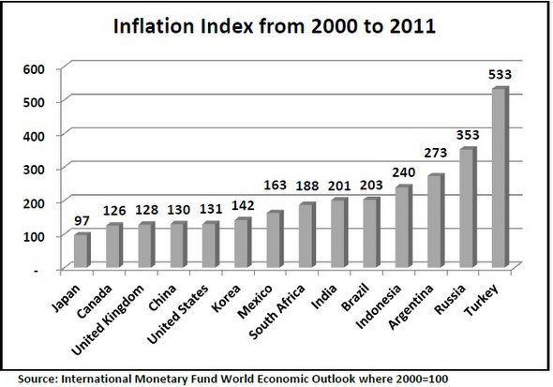

What causes inflation?

Prices rise either because business are forced to increase them as
- Their costs are rising
- Or businesses take advantage of high consumer demand to make extra profits and raise prices

Cost-push causes of inflation
Demand–pull causes of inflation

Cost-push inflation  Firms face higher costs of production - they may then raise prices to maintain profit margins | Demand-pull  Consumer demand in an economy is rising (boom)
A lower exchange rate pushes up the prices of imported materials  World demand for materials raises their prices  Higher wage demands from workers e.g. could be in response of previous inflation – workers usually expect to maintain their real living standards | Producers and retailers realise they can raise prices of existing stocks  If they do not raise prices, stocks could be sold out  Avoids unsatisfied demand: supply shortages led to excess demand in Zimbabwe  Businesses will earn higher profits by raising prices

Cause of inflation | Government and central bank policy | Impact on business strategy of government policy aiming to control inflation
Cost-push | - High exchange rate policy- higher interest rates set by bank  - Discourage high wage settlements – may use public sector workers as an example | Exports less competitive – switch to domestic market  Higher interest rates deter borrowing and investment – cancel business projects  Consumer credit will be discouraged – reducing demand for expensive goods such as cars  Firms often ignore government views on labour – market forces are more important
Demand-pull | - Policies designed to reduce demand such as higher tax rates and lower government spending  - Central bank is likely to raise interest rates | Higher taxes reduce consumer demand - progressive taxes are increased, a swing away from luxury goods – change in product mix  Lower government spending could hit certain industries very hard – defence equipment suppliers or hospital equipment manufacturers – may enter foreign markets  Interest rate increases - same effects as above

Impact on business strategy:

Inflation can have the following benefits for business if the rate is quite low:
- Cost increases can be passed onto consumers more easily
- The real value of debts owed by companies will fall
  - Because the value of money is falling, when a debt is repaid, it is repaid with money of less value than the original loan

- Rising prices are also likely to affect assets held by firms, so the value of fixed assets such as land and building, could rise
  - Increase value of a business (at least on the balance sheet)

- Since stocks are bought in advance and then sold later, there is an increased profit margin from the effect of inflation (buying with cheaper money)

Therefore, during periods of low inflation, businesses could decide:
- to raise their own prices
- borrow more to invest
- ensure that increased asset value appears on their balance sheet

However, higher rates of inflation, say above 6-7% per year can have very serious drawbacks for business:

- Employees will become much more concerned about the real value of their incomes – increase in industrial disputes and demands
- Consumers are likely to become more price sensitive
- Rapid inflation will often lead to higher rates of interest – highly geared companies may find it difficult to make interest repayments
- Cash-flow problems – firms struggle to find the money to pay the higher costs of materials and other costs
- Inflation causes uncertainty –
  - More prices rises?
  - Rate of inflation continue to increase?
  - Government reaction – effect on the firm

Uncertainty makes forecasting more difficult and less reliable
- Sales forecasts and investment appraisals (future cash flows -we’ll do that later)

- If inflation is higher in one country than another – business will lose competitiveness in overseas markets

- Business that sell goods on credit – reluctant to offer extended credit periods – repayments by creditors in money that is losing value rapidly

- Consumers may stockpile some items and cut-back on non-essential items of spending

Business strategy during a period of rapid inflation might focus on:

- Cutting back on investment spending

- Cutting profit margins to limit own price rises to stay as competitive as possible

- Reducing borrowing to levels at which interest payments are manageable

- Reducing time period for customers (debtors) to pay

- Reducing labour costs

Does this mean deflation is beneficial?

One would consider the detrimental effect that inflation has so deflation would be seen as a good thing…however:
- Consumers would delay making important purchase hoping that prices will fall further – reduction in demand – leads to recession
- Business with LTL make repayments with money that has gained value since the original loan was taken out – discourage borrowing to invest
- As prices fall, future profitability of projects appears doubtful – again, firms are unwilling to invest
- Holding of stocks of materials and finished goods fall in value:
  - businesses hold as few stocks as possible
  - reduce order for supplies from other businesses
  - could push economy to recession because output will decline

So can a business win either way?

A general consensus is that the optimum position for most economies is LOW INFLATION – an aim to keep it a predetermined target such as the UK and Eurozone CPI of 2% rise p.a.

Worksheet summary quiz and activity:

- How are some businesses likely to be negatively affected by rapid rates of growth?

- Outline three macro-economic objectives of China.

- Consider inflation in China over the last few years. What impact has it had on people and businesses?
Summary of the worksheet in your own words (in English and Chinese):

Vocabulary check:
English | Chinese

