Enterprise - business activity and added value

Introduction:

- What business activity involves
- What is ‘value added’?– How we ‘add value’ to a product or service

Let’s start by discussing what a business is. In your own words, can you explain what businesses do and why they exist? How do they do it?

In pairs, can you give your own brief example of:

 | Name: | Products/Services: | Why?
A very successful company
A failing/failed company

The purpose of business activity:

A business is any organisation that uses resources to meet the n_____ds of customers by providing a pro_______t or serv______e that they demand.

There are several stages in the production of finished goods.

Businesses take raw ma________s like leather and make them into sho___ or handbags.
Businesses take the raw materials and make them more DESIRABLE (things we want/desire) and therefore ADD VALUE to the finished good.

Consider a school textbook:
What raw materials does it use? ______________________________

Who (which businesses) makes revenue (money, sales) from a book?

Business activity uses the scarce resources of our planet to produce goods and services that allow us to have a higher sta__________d of living.

Businesses identify:
- Needs of cons_________s or other firms (businesses)
- Purchase res_________s (or factors of production)
- To produce goods or services that satisfy needs
- Usually aim to make a prof_____

KEY DEFINITIONS:
Consumer goods: | Consumer services: | Capital goods:
Physical and tangible goods sold to the general public (you can touch)  Durable consumer goods: such as cars and washing machines (used many times)  Non-durable consumer goods such as foods, drinks, sweets (that can be used only once) | Non-tangible products sold to the general public– hotel accommodation, insurance services and train journeys | Physical goods used by industry to help in the production of other goods and services, such as machines and commercial vehicles (i.e. for construction)
What do businesses need to produce goods and service?

Factors of production

Land | A general term includes not only land itself, but all renewable and non-renewable resources of nature, such as coal, crude oil and timber (wood).
Labour | Manual and skilled labour (workers) make up the workforce of the business.
Capital | Not just the finance to set up the business and run it, but all the man-made resources used in production. These include capital goods such as computers, machines, factories, offices and vehicles.
Enterprise | This is the ‘driving force’, provided by risk-taking individuals, that combines the other factors of production into a unit capable of producing goods and services.

Notes:

What businesses need:
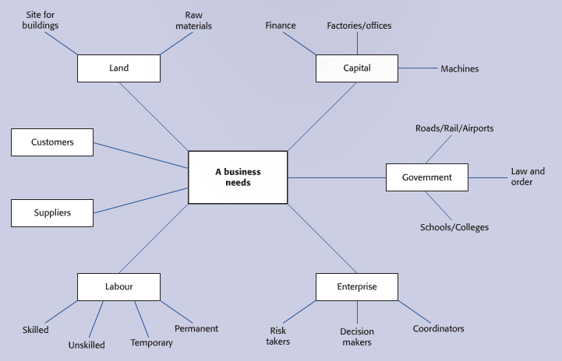
Fig 1.1
Consider the school as an organisation (business): what does the school need?

The concept of adding value (added value)

A business adds value to the raw materials it uses to produce the good or service it sells. Added value is one of the key objectives of any business.

If a customer is prepared to pay a price that is much greater than the cost of materials used in making or providing a good or service, then the business has been successful in ‘adding value’.

From the value added by the business, other costs have to be paid, such as labour and rent – value added is NOT the same as profit.

However, if a business can increase its value added without increasing its costs, then profits will increase.

1 –Jewellers: a well designed shop-window display, attractive shop fittings, well-dressed and knowledgeable shop assistants and beautiful boxes offered to customers to put new jewellery in.

2 –Sweet manufacturer: extensive advertising of brands of sweets to create an easily recognised name and brand identity, attractive packaging, selling through established confectionary shops and not ‘cheap’ vending machines.

Worksheet summary quiz and activity:

- Explain what ‘business activity’ is?

- How would a travel agency ‘add value’ to its products and services?

True or False (Mark an X)

I will choose a random student to answer a question | True | False
- Most businesses need a trusted, reliable supplier to be successful.

- Without business activity, we would be dependent on ourselves to grow food and make things ourselves.

- Most of the world’s trade is Business to Business (B2) rather than to individual customers like us or our parents.

- Technology plays a large part in business activity because of its ability to innovate and be efficient.

- You cannot learn how to be a good business person.

Summary of the worksheet in your own words (in English and Chinese):

Vocabulary check:

English | Chinese
Labour
Activity
Enterprise
Value
Dealer
Manufacturer
Packaging

NB: Many words are used to describe a business: an organisation, a firm, a company, a corporation, an enterprise. We will discuss the differences during the course.

