Business size – comparisons

Introduction:

- How do we evaluate businesses?
- The difference between the sole trader and the huge public limited company

Businesses vary hugely in size: from the sole trader with one worker to the multinationals with hundreds of thousands of workers (100, 000s).

Measuring the size of businesses is an inexact science but we often try to gage/measure some understanding so that comparisons can be made.

Why do we need to understand and compare?
What do investors need to know?

Why do governments need to know?

How do businesses differ?

Measuring business size:
- Governments may need to assist ‘small firms’ – so what is a ‘small firm’?
- Investors may need to decide which company to invest in. So how do they decide?
- Which business is growing? Which business is shrinking?
- Customers may want to buy from big firms as they offer stability, stronger brands with continuity or from small localised firms with a more personal service.

The two challenges are:
- Different ways of measuring and comparing businesses and they often give different comparative results.
- No internationally agreed definition of what a small, medium or large business, although number of employee is common (what about an automated company with few workers and high output?)

Different measures of size:
- Number of employees
- Easy to understand but can mislead with highly automated firms
Example:
Two soft drink firms in town:
- One uses traditional methods to produce 300,00 litres per week with 108 staff
- The other it totally automated and produces 1,000,000 litres per week with just 10 staff

The EU has criteria for measuring business size:
 | Employees | Sales turnover | Capital employed
Micro firm
Small firm
Medium firm

- Sales turnover:

Often used with comparing firms in the same industry. It’s more difficult and less effective when measuring different industries. Some may produce high value goods like jewellery and some might be in low value production such as cleaning services.

The level of turnover – ann_____l sales – is the most widely used indicator of a firm’s size. It suggests the ability to obtain finance and benefit from economies of scale.

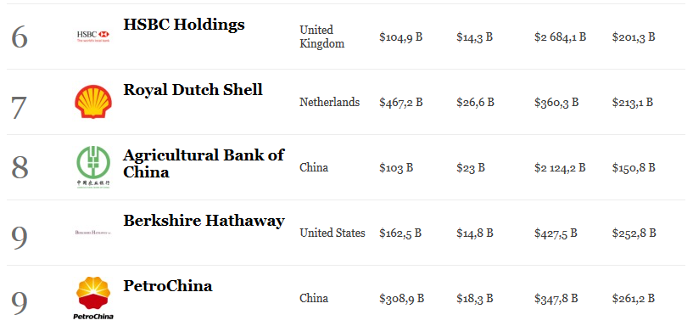

Which has the largest sales?

There are limitations of using as a measure of size:
- An organisation’s turnover varies from greatly year to year
- Firms that have similar turnover figures may have quite different profits because profit margins vary between industries
- Turnover is not necessarily an indicator of market share or market value

- Capital employed

Generally, the larger the business enterprise, the greater value of capital needed for long-term investment, or the greater capital employed.

Difficulties arise from comparing different industries with different capital needs such as a hairdresser or optician.
- They may employ the same amount of staff but an optician may need expensive diagnostic and eyesight measuring machines.

Capital employed shows net investment and is compared with profit to assess profitability. It can be a difficult figure to measure – firms in the same industry may use difference bases for valuing assets, which affects capital employed figures and can lead to inaccurate comparisons.

- Market capitalisation

Market capitalisation can be used only for businesses that have shares ‘quoted’ on the stock exchange (public limited companies). It is calculated by this formula:

Market capitalisation = current share price x total number of shares issued

As share prices tend to change every day, this form of comparison is not a very stable one.
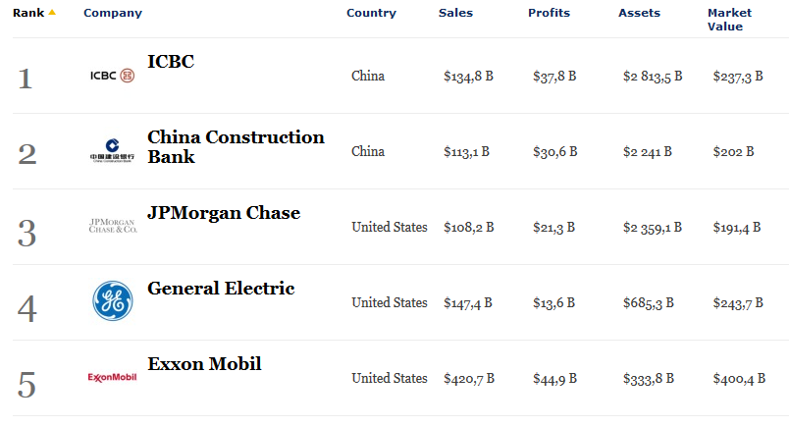
Forbes Global 2000 are the biggest, most powerful listed companies in the world.

Their justification for using a composite ranking is simple: One metric alone can give a false impression about corporate size. Our ranking of the world’s biggest companies departs from lopsided lists based on a single metric, like sales. Instead we use an equal weighting of sales, profits, assets and market value to rank companies according to size.

Do you agree with their assessment?

- Market share

Market is a relative measure. If a firm has a high market share, it must be among the leaders in the industry and comparatively large. However, when the size of the total is small, a high market share will not indicate a very large firm.

$\frac{total sales of business}{total sales of industry }$ x 100

Is it easy to measure a market?

Consider the case of XiaoMi smartphones and Apple’s iPhones:

- Who has the biggest market share in China?

We may draw conclusions as to the largest company but in this case, perhaps market share is an important indicator for strategy and of course, stakeholders.

Further, we may also consider a niche market: a company may have 90% market share but the actual total market is only small.

- We have 90% of the market share – but the market is only worth $1M
- Are we a large firm?

- Profit
Profit is a good indicator of relative success and that a company with higher profits than others may be classed as a larger company. Different industries have typically different profit margins. Some industries rely on quality whereas some on quantity (volume) – sell few at a high price or sell many at a low price. Wal-Mart operates on profit margins of around 3.5%: but it sells huge amounts of goods so that the total profits are large. There is usually a trade-off between quantity and quality. Look up ‘Risk-bearing theory of profit’.

Which company has the largest profits?

Other measures:
- Hotels typically measure the number of beds or guest rooms
- Retailers could use the number of shops
- Retailers also use total floor space as a measure (and sales/per m²⁾

Which form of measurement is the best?
There is no ‘best’ measure:
- What is being measured?
- Comparative or absolute?
- Company or Industry?
- Perhaps make a comparison based on two of the criteria

Activity 3.1

Worksheet summary quiz and activity:

- Why is business size so subjective and hard to do?

- List three stakeholder groups that might wish to compare the size of one business to another and why

True or False (mark an X)

 | True | False
- Each industry is different, so they have different metrics for success.

- If a firm has a large market share, it must be a large company.

- Limited companies (Ltds) are often measured by their market capitalisation.

- Governments need to know the size of firms for forecasting tax revenues.

- Different countries have different criteria for firm size.

Summary of the worksheet in your own words (in English and Chinese):

Vocabulary check:

English | Chinese
Relative
Objective
Comparative
Absolute
Quoted

