Business structure – synergy and integration

Introduction:

- The idea of synergy and integration: is the ‘whole greater than the sum of the parts’? Or when two entities are combined, are they just more complicated?
- An expansion of the joint venture: how strategic alliances are formed and why.

With a merger, an agreement is made by the shareholders and managers of the two businesses to bring both firms together under a common board of directors. Shareholders in both businesses own shares in the newly merged business.

Can you name some significant mergers?
Why do you think they merged?

A takeover is:

You may see the acronym M&A to refer to Mergers and Acquisitions

When two firms are integrated the argument is that the bigger firm created in this way will be more effective, efficient and profitable than the two separate companies.

Why?

While in theory it is a good idea, many mergers and takeovers FAIL to gain true synergy, and the shareholders are often left wondering what the purpose of the integration really was.

Many examples of business integration have not increased shareholder value because:

- Too big to manage:

- Little mutual benefits: perhaps firms are too different:

- Business and management culture:
Here is a current example:

ALMOST three years have passed since United Airlines and Continental Airlines merged to create one of the world's largest carriers.

The combined entity, which took United's name, has the biggest fleet of commercial airliners on the planet and flies to more destinations than any competitor. But three years in, the merger is still causing problems.

Late last month, for example, America's Department of Transportation fined United $350,000 for taking too long to process its customers' refund requests. (The airline also got in trouble for reporting some of its overbooking, baggage, and pet-related statistics incorrectly, but was not fined for those violations.)

Here's the remarkable thing about this latest fine, which was connected to delays of some 9,000 refund requests: United blamed it on the merger. According to the Los Angeles Times, United told the regulators that when the two legacy airlines' reservation systems were merged it resulted "in some unforeseeable anomalies that caused a temporary inability to process refunds in a timely manner."

That's unacceptable. Again, it's been nearly three years since the merger. "Unforeseeable anomalies" should have been corrected by now. And on what sort of scale is it appropriate to describe a three-year-old problem as "temporary?"

This isn't the first time United has run into computer trouble: it has had repeated technology problems since the merger. Its technology team has had more than enough time to sort things out and get them working smoothly.

So are there not enough resources devoted to tackling these sorts of problems? Or is there a management issue?

United needs to figure it out. Because, as the Denver Post reports, there are a lot of other problems still plaguing this sewn-together giant. It has horribly inefficient labour contracts that require formerly United crews to fly on United aircraft and formerly Continental crews to fly on Continental aircraft. Can investors be confident that United will resolve its labour issues if it can't even get its computer systems working correctly?
(taken from the article: The United-Continental merger - Truly united? Sep 9th 2013 – The Economist)

Questions to consider:

- Is it okay to blame problems on mergers?
- Often labour laws and unions become involved in mergers. Is it possible to truly integrate employees from different firms?

Potential Problem | Effect on Business | Solutions
Financial
Managerial
Marketing
Loss of Control

An example of mergers and anti-trust:

The unexpected challenge by the United States Department of Justice (DoJ) to the proposed merger of American Airlines and US Airways on August 13th marks an abrupt change of policy after a decade during which regulators (mostly) favoured consolidation in a chronically loss-making industry.

Since de-regulation more than 30 years ago American carriers have either been in dire financial straits or only briefly in profit, and attacked on all sides for gouging (extract) passengers with higher fares.

Opposition to consolidation was often strong on Capitol Hill (US government) because senators and congressmen feared for their political lives if routes to their home towns were cut and their voters had to change planes rather than fly directly where they wanted. Americans depend so much on network and budget airlines for domestic as well as foreign travel that they moan about them the way Britons complain about privatised railways and expensive train prices.

The thrust of the case is based on the merger’s effect on ticket prices and various additional charges that airlines have introduced to increase revenues.

But the DoJ said the merger would take consolidation too far, leaving four airlines controlling over 80% of the American market.

(taken from the article: The government opposes a big airline merger - Not the American way, Aug 14th 2013, The Economist)

Things to consider:

- Is this a political or economical decision?
- Is there an argument that the mergers might be good for customers if they can integrate efficiently?

Joint ventures and strategic alliances

We have already discussed JVs (and IJVs) as an external form of growth without integration or changes in ownership.

Strategic alliances are:

Alliances can be made with a wide variety of stakeholders:

- With a university

- With a supplier

- With a competitor

Let’s look at a popular form of strategic alliance: Airlines

An airline alliance is an agreement between two or more airlines to cooperate on a substantial level.

The three largest passenger airline alliances are:

- Star Alliance
- SkyTeam
- Oneworld

Alliances also form between cargo (freight, distribution) airlines, such as that of WOW Alliance, SkyTeam Cargo, and ANA/UPS Alliance.

Alliances provide a network of connectivity and convenience for international passengers and international packages.

Alliances also provide convenient marketing branding to facilitate travellers making inter-airline codeshare connections within countries.

This branding goes as far as to even include unified aircraft liveries (uniforms) among member airlines.

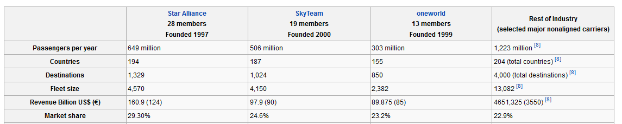

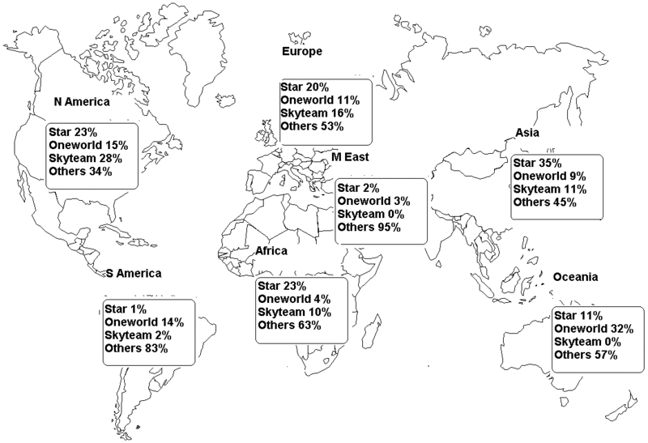
Benefits | Disadvantages
- An extended network: this is often realised through code sharing agreements. Many alliances started as only a code sharing network.

- Cost reduction from sharing of:
  - Sales offices
  - Maintenance facilities
  - Operational facilities, e.g. catering or computer systems.
  - Operational staff, e.g. ground handling personnel, at check-in and boarding desks.
  - Investments and purchases, e.g. in order to negotiate extra volume discounts.

Benefits for travellers | Drawbacks for travellers
- Lower prices due to lowered operational costs for a given route.  - More departure times to choose from on a given route.  - More destinations within easy reach.  - Shorter travel times as a result of optimised transfers.  - A wider range of airport lounges shared with alliance members  - Faster mileage rewards by earning miles for a single account on several different carriers (loyalty schemes)  - Round-the-world tickets, enabling travellers to fly over the world for a relatively low price. | - Higher prices when all competition is erased on a certain route.  - Less frequent flights: for instance, if two airlines separately fly three and two times a day respectively on a shared route, their alliance might fly less than 5(3+2) times a day on the same route. This might be especially true between hub cities for each airline. e.g., flights between Detroit (a Delta Air Lines fortress hub) and Amsterdam (a KLM fortress hub).
Mergers and Takeovers in brief

Takeovers:
- Quick and easy way to expand the business
- Often cheaper than growing internally
- Some businesses have (spare) cash available

Mergers may be strategic: for defensive reasons; Consolidation; Prevent itself from being overtaken.

Mergers may occur for the same reasons as IJVs – avoid restrictions, protectionism; asset strip; management objective is growth (although some directors are accused of ‘empire building’ as a statement of power, legacy or for personal image).

Merger ‘boom’ in the later 1990s:
- some sectors go through a phase of high profits
- greater global competition
- deregulation and liberalisation of industries
- IT improvements; intranets
- ‘Bargain hunting’ in due economic crises in certain areas (Asian 1997)

Notes:

Worksheet summary quiz and activity:

- Why does it make sense to have an alliance with a competitor?

- Mergers seldom go smoothly. Can you outline the potential reasons for this?

True or false (mark an X)

 | True | False
- Microsoft’s takeover of Nokia’s handset division is an example of horizontal integration

- Large MNC’s often create strategic alliances with universities such as Harvard or MIT.

- Rapid growth is the objective of all firms.

- Mergers are not covered by anti-trust legislation

- Some directors acquire companies for more than just economic reasons.

Summary of the worksheet in your own words (in English and Chinese):

Vocabulary check:
English | Chinese
Acquisition
Handset
Livery
Holistic
Liberalisation

